Calculating Financial Returns - Plotting Returns
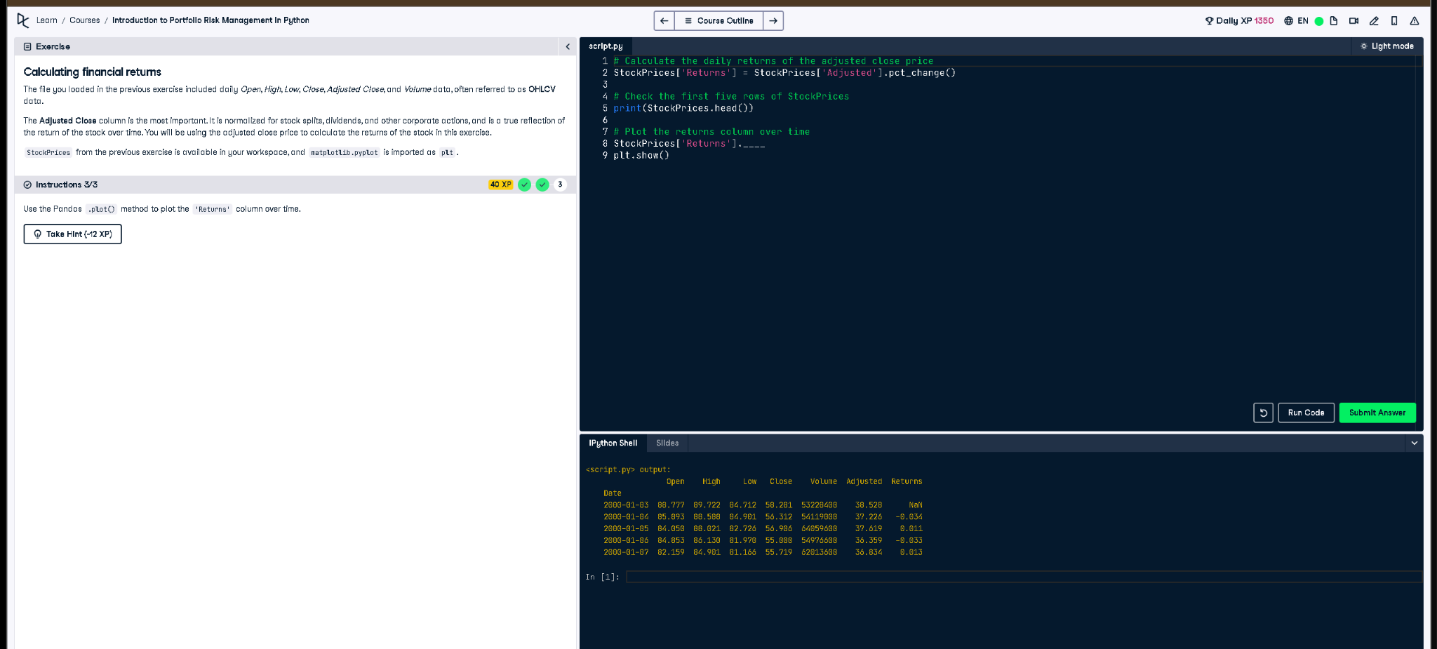

Python Code:
# Calculate the daily returns of the adjusted close price
StockPrices['Returns'] = StockPrices['Adjusted'].pct_change()
# Check the first five rows of StockPrices
print(StockPrices.head())
# Plot the returns column over time
StockPrices['Returns'].plot()
plt.show()

Explanation (in simple words):
This code calculates daily stock returns using the adjusted close price. It finds the percent change between days with .pct_change(), adds the result to a 'Returns' column, shows the first five rows with .head(), and then plots those returns over time using the Pandas plot method and matplotlib.

